|  |  |
| --- | --- |
| **Student Name** | **Om Atul Mahadeokar** |
| **SRN No** | 202200340 |
| **Roll No** | 17 |
| **Program** | Computer Engg. |
| **Year** | Third Year |
| **Division** | B |
| **Subject** | Computer Network Laboratory (BTECCE21506) |
| **Assignment No** | 1 |

Assignment Number - 06

**Title :** Configuration of router for implementation of Open Shortest Path First (OSPF) Protocol

**Problem Statement** Using a Network Simulator (e.g. packet tracer) Configure routers for OSPF routing

**Theory :**

**OSPF Protocol**

OSPF is a complex routing protocol. It uses many terms to define its functions and operations.

**Link**

A link is a router's interface connected to an IP subnet. When we add an interface to the OSPF process, OSPF considers the interface as a link.

**State**

Since a link is an interface, it has two states: up and down. The up state shows the link (interface) is operational and OSPF can reach the IP subnet connected to the link. The down state shows the link is not operational and OSPF cannot reach the IP subnet connected to the link.

**Link state protocol**

OSPF is a link-state protocol. Link state protocols use the Shortest Path First (SPF) algorithm to calculate the best path to a destination. To run this algorithm, link-state protocols learn the complete topology of the network. In a big size network, this feature creates scalability problems. To solve this problem, OSPF uses two concepts: autonomous systems and areas.

**An autonomous system**

|  |  |
| --- | --- |
| **Term** | **Description** |
| Backbone area | A special area to which all other areas must connect. |
| area | A set of contiguous routers that share the same routing information. |
| Backbone routers | Routers in the backbone area |
| Internal routers | Routers in areas off the backbone |
| ABR | A router that connects the area to the backbone area |
| Intra-area route | A route within the same area |
| Interarea route | A route between the areas |

An autonomous system is a group of networks under a single administrative control which can be a group of companies, a company, or a division within the company. There are two types of routing protocols: Interior Gateway Protocol (IGP) and Border Gateway Protocol (BGP). IGP routing protocols provide routing within a single AS. BGP routing protocols provide routing between different AS. OSPF is a IGP routing protocol. OSPF provides routing within a single AS.

**OSPF Area**

OSPF groups network together, where the topology of one group is hidden from the other. These set of groups are called Areas. An area ID is 32 bit number, which is unique identification number that differentiates each area.

**Backbone area (Area 0) –** Responsible for distributing routing information among other areas of the system. The backbone area is identified by the number 0.0.0.0

**Off backbone area (Area 1-65535) –** consist of areas other than backbone area of system.

**Configuration of OSPF**

The systax for configuring OSPF is:

Router(Config)#router ospf process_ID

Router(Config)#network Network_address Wildcard_mask area are_no

**OSPF Implementation in Single Area**

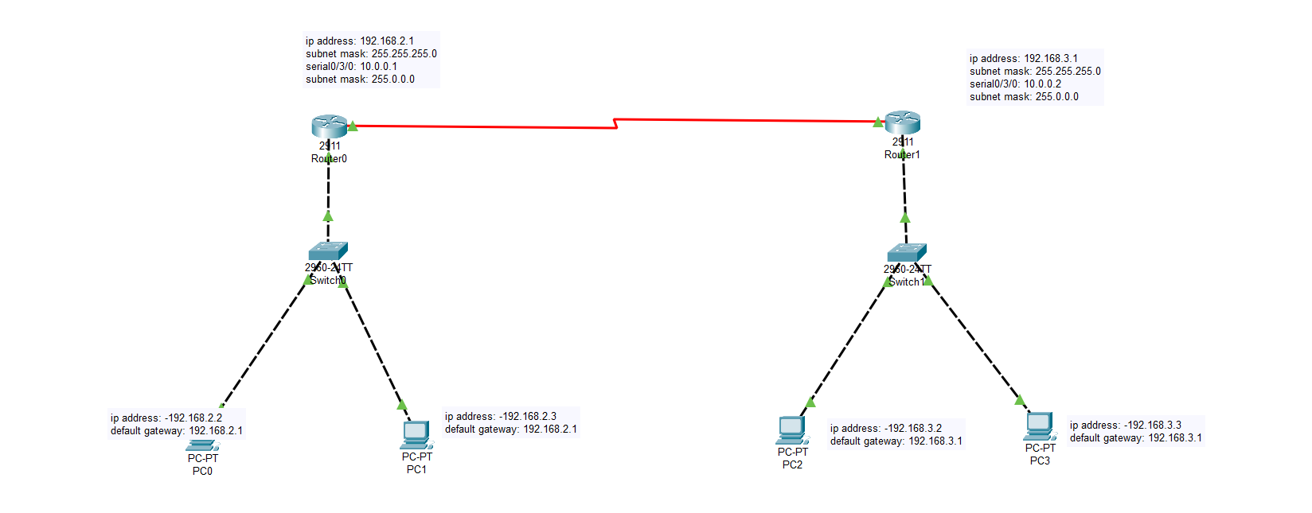

**Code :**

**OSPF –Multiple Single**

**Router 0**

Router>enable

Router#

Router#configure terminal

Enter configuration commands, one per line. End with CNTL/Z.

Router(config)#interface Serial0/3/0

Router(config-if)#

Router(config-if)#

Router(config-if)#interface Serial0/3/0

Router(config-if)#ip address 10.0.0.1 255.0.0.0

Router(config-if)#no shutdown

%LINK-5-CHANGED: Interface Serial0/3/0, changed state to down

Router(config-if)#

Router(config-if)#

Router(config-if)#exit

Router(config)#interface Serial0/3/0

Router(config-if)#exit

Router(config)#

%LINK-5-CHANGED: Interface Serial0/3/0, changed state to up

%LINEPROTO-5-UPDOWN: Line protocol on Interface Serial0/3/0, changed state tinterface Serial0/3/0interface GigabitEthernet0/0

Router(config-if)#ip address 192.168.2.1 255.255.255.0

Router(config-if)#no shutdown

Router(config-if)#

%LINK-5-CHANGED: Interface GigabitEthernet0/0, changed state to up

%LINEPROTO-5-UPDOWN: Line protocol on Interface GigabitEthernet0/0, changed state to up

exit

Router(config)#

Router(config)#

Router(config)#interface GigabitEthernet0/0

Router(config-if)#

Router(config-if)#

Router(config-if)#exit

Router(config)#interface GigabitEthernet0/2

Router(config-if)#

Router(config-if)#exit

Router(config)#interface Serial0/3/0

Router(config-if)#

Router(config-if)#exit

Router(config)#interface GigabitEthernet0/0

Router(config-if)#

Router(config-if)#

Router(config-if)#exit

Router(config)#

Router(config)#

Router(config)#

Router(config)#interface GigabitEthernet0/0

Router(config-if)#ip address 192.68.2.1 255.255.255.0

Router(config-if)#ip address 192.68.2.1 255.255.255.0

Router(config-if)#

Router(config-if)#exit

Router(config)#interface Serial0/3/0

Router(config-if)#

Router(config-if)#exit

Router(config)#router ospf 1

Router(config-router)#network 192.68.

Router(config-router)#

Router(config-router)#end

Router#configure terminal

Enter configuration commands, one per line. End with CNTL/Z.

Router(config)#interface GigabitEthernet0/0

Router(config-if)#

%SYS-5-CONFIG_I: Configured from console by console

ip address 192.168.2.1 255.255.255.0

Router(config-if)#ip address 192.168.2.1 255.255.255.0

Router(config-if)#

Router(config-if)#exit

Router(config)#exit

Router#

%SYS-5-CONFIG_I: Configured from console bconfigure terminalconfigure terminalconfigure terminal

Enter configuration commands, one per line. End with CNTL/Z.

Router(config)#router ospf 1

Router(config-router)#network 192.168.2.0 0.0.0.255 area 0

Router(config-router)#network 10.0.0.1 0.255.255.255 area 0

Router(config-router)#exit

Router(config)#exit

Router#

%SYS-5-CONFIG_I: Configured from console by console

Router#copy running-config startup-config

Destination filename [startup-config]?

Building configuration...

[OK]

Router#

?Bad filename

%Error parsing filename (Bad file number)

Router#

Router#configure terminal

Enter configuration commands, one per line. End with CNTL/Z.

Router(config)#router rip

Router(config-router)#

Router(config-router)#end

Router#configure terminal

Enter configuration commands, one per line. End with CNTL/Z.

Router(config)#interface Serial0/3/0

Router(config-if)#

%SYS-5-CONFIG_I: Configured from console by console

Router(config-if)#exit

Router(config)#router rip

Router(config-router)#

Router(config-router)#end

Router#configure terminal

Enter configuration commands, one per line. End with CNTL/Z.

Router(config)#interface GigabitEthernet0/0

Router(config-if)#

%SYS-5-CONFIG_I: Configured from console by console

Router(config-if)#exit

Router(config)#

Router(config)#

Router(config)#router rip

Router(config-router)#

00:35:12: %OSPF-5-ADJCHG: Process 1, Nbr 192.168.3.1 on Serial0/3/0 from LOADING to FULL, Loading Done

**Router 1**

Router>enable

Router#configure terminal

Enter configuration commands, one per line. End with CNTL/Z.

Router(config)#interface Serial0/4/0

Router(config)#exit

Router#

%SYS-5-CONFIG_I: Configured from console bconfigure terminalconfigure terminal

Enter configuration commands, one per line. End with CNTL/Z.

Router(config)#interface Serial0/3/0

Router(config-if)#ip address 10.0.0.2 255.0.0.0

Router(config-if)#no shutdown

Router(config-if)#

%LINK-5-CHANGED: Interface Serial0/3/0, changed state to up

Router(config-if)#

%LINEPROTO-5-UPDOWN: Line protocol on Interface Serial0/3/0, changed state to up

Router(config-if)#

Router(config-if)#exit

Router(config)#interface Serial0/3/0

Router(config-if)#

Router(config-if)#exit

Router(config)#interface GigabitEthernet0/0

Router(config-if)#interface FastEthernet0/0

%Invalid interface type and number

Router(config)#

Router(config)#

Router(config)#interface GigabitEthernet0/0

Router(config-if)#interface GigabitFastEthernet0/0

^

% Invalid input detected at '^' marker.

Router(config-if)#

Router(config-if)#

Router(config-if)#exit

Router(config)#interface GigabitEtinterface GigabitEthernet0/0interface GigabitEthernet0/0

Router(config-if)#ip address 192.168.3.1 255.255.255.0

Router(config-if)#no shutdown

Router(config-if)#

%LINK-5-CHANGED: Interface GigabitEthernet0/0, changed state to up

%LINEPROTO-5-UPDOWN: Line protocol on Interface GigabitEthernet0/0, changed state to up

Router(config-if)#

Router(config-if)#exit

Router(config)#interface GigabitEthernet0/0

Router(config-if)#

Router(config-if)#

Router(config-if)#exit

Router(config)#interface GigabitEthernet0/0

Router(config-if)#

Router(config-if)#exit

Router(config)#interface Serial0/3/0

Router(config-if)#

Router(config-if)#

Router(config-if)#exit

Router(config)#interface GigabitEthernet0/0

Router(config-if)#ip address 192.68.3.1 255.255.255.0

Router(config-if)#

Router(config-if)#

Router(config-if)#

Router(config-if)#exit

Router(config)#interface GigabitEthernet0/0

Router(config-if)#ip address 192.168.3.1 255.255.255.0

Router(config-if)#ip address 192.168.3.1 255.255.255.0

Router(config-if)#

Router(config-if)#exit

Router(config)#router ospf 1

Router(config-router)#network 192.168.3.0 0.0.0.255 area 0

Router(config-router)#network 10.0.0.2

Router(config-router)#

Router(config-router)#end

Router#configure terminal

Enter configuration commands, one per line. End with CNTL/Z.

Router(config)#interface Serial0/3/0

Router(config-if)#

%SYS-5-CONFIG_I: Configured from console by console

Router(config-if)#exit

Router(config)#router ospf 1

Router(config-router)#network 10.0.0.2 0.255.255.255 area 0

Router(config-router)#exit

Router(config)#exit

Router#

%SYS-5-CONFIG_I: Configured from console by console

Router#

00:35:01: %OSPF-5-ADJCHG: Process 1, Nbr 192.68.2.1 on Serial0/3/0 from LOADING to FULL, Loading Done

Router#copy running-config startup-config

Router#configure terminal

Enter configuration commands, one per line. End with CNTL/Z.

Router(config)#exit

Router#

%SYS-5-CONFIG_I: Configured from console by console

Router#copy running-config startup-config

Destination filename [startup-config]?

Building configuration...

**Conclusion:** In conclusion, configuring OSPF routing on routers using a network simulator like Packet Tracer ensures efficient and dynamic route management across a network. OSPF, as a link-state protocol, calculates the shortest path for data transmission using the Shortest Path First (SPF) algorithm. The protocol's use of areas helps improve scalability in larger networks, with Area 0 functioning as the backbone for routing information. Through commands like assigning IP addresses, enabling interfaces, and defining OSPF network configurations, routers efficiently exchange routing information, ensuring optimized and seamless network communication.